NAME : B.SHIVA TEJA
ROLL NO : 2403A51025
BATCH NO : 01

Subgroup J

J.1 — [S13J3] Normalize sensor readings
Scenario (agritech):
Context: Sensor data logs in agritech are stored as CSV-like text. Each line contains sensor_id, timestamp, value. For downstream ML, values must be normalized.
Your Task:
Parse the text into structured data, compute z-score normalization for each sensor’s values independently (per sensor_id), and return results as a dict mapping sensor_id → list of (timestamp, z_value).
Data & Edge Cases:
- Input text may have blank lines.
- Each sensor_id should be normalized independently.
- If a sensor has only one value, return z=0 for all its rows.
AI Assistance Expectation:
Ask AI to suggest pandas/numpy vs pure Python approaches, discuss numerical stability, and test edge cases.
Constraints & Notes:
- Output as dict[str, list[tuple[str, float]]].
- Round z-scores to 3 decimals for consistency.
Sample Input
s1,2025-01-01T10:00,10
s1,2025-01-01T11:00,20
s2,2025-01-01T10:30,100
s2,2025-01-01T11:30,100
Sample Output
{
's1': [('2025-01-01T10:00', -1.0), ('2025-01-01T11:00', 1.0)],
's2': [('2025-01-01T10:30', 0.0), ('2025-01-01T11:30', 0.0)]
}
Acceptance Criteria:
- Correct per-sensor z-score calculation.
- Handles one-value case with zeros.
- Ignores blank lines safely.
TASK_1 :
PROMPT :
Generate the text into structured data, compute z-score normalization for each sensor’s values independently (per sensor_id), and return results as a dict mapping sensor_id list of (timestamp, z_value).
CODE :
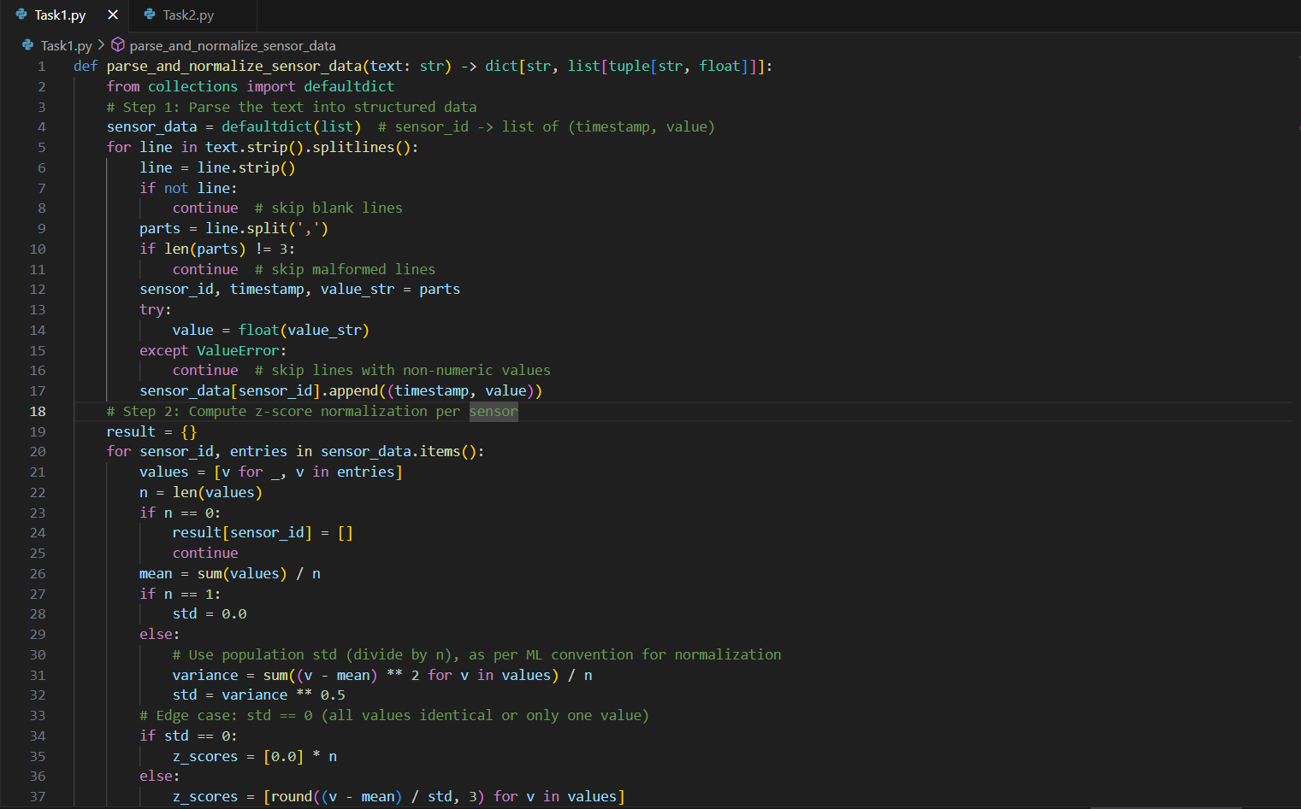
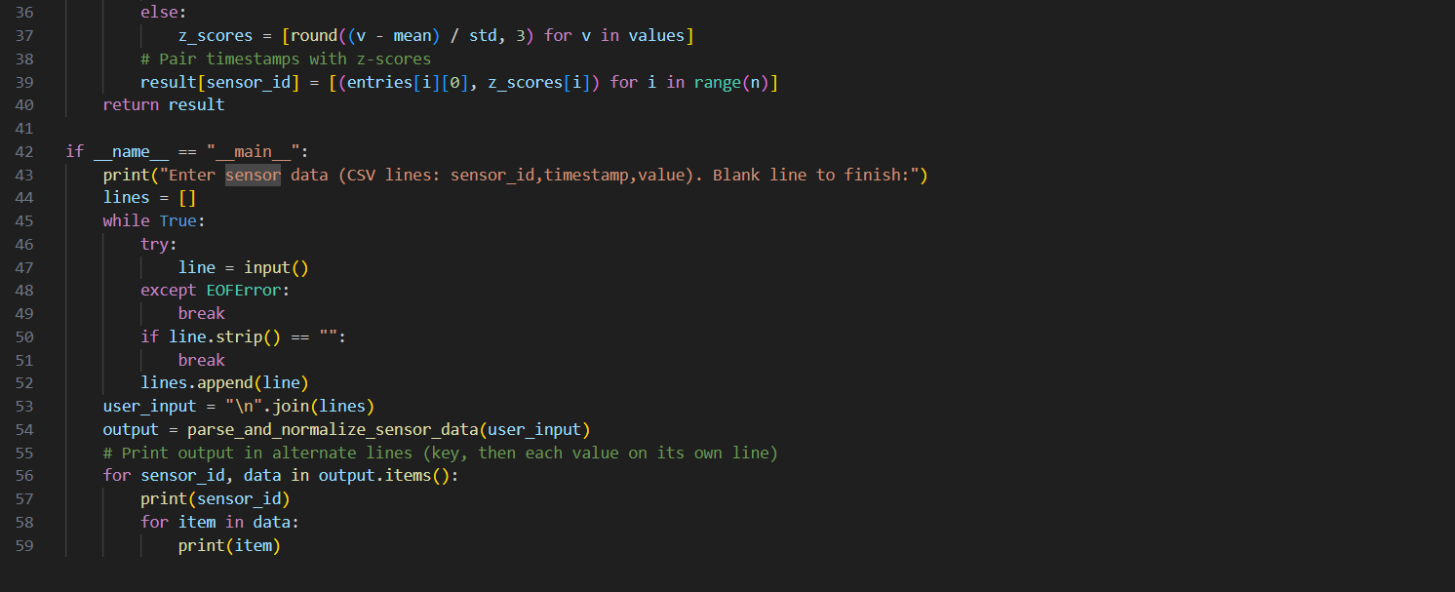
OUTPUT :
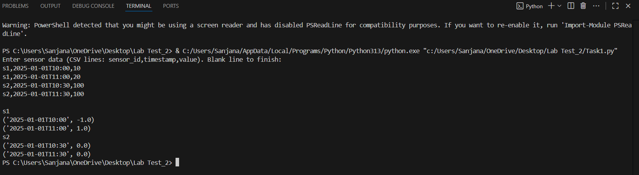

J.2 — [S13J4] Detect overlapping irrigation schedules
Scenario (agritech):
Context: Smart irrigation systems schedule watering by time slots per field. Overlaps between schedules can cause overwatering or pressure issues.
Your Task:
Given a list of schedules (field_id, start_time, end_time in ISO format), detect pairs of fields with overlapping watering times.
Data & Edge Cases:
- Input is a list of dicts.
- Times are inclusive at start, exclusive at end.
- Return list of tuples (fieldA, fieldB) where overlap occurs.
- If no overlaps, return empty list.
- Ensure each pair is unique (no duplicates, order sorted lexicographically).
AI Assistance Expectation:
Ask AI to propose interval overlap detection strategies (sorting by start, sweep-line, or O(n²) check depending on data size).
Constraints & Notes:
- Return list[tuple[str,str]].
- Assume all times in same timezone (no conversion needed).
Sample Input
[
{'field': 'F1', 'start': '2025-01-01T08:00', 'end': '2025-01-01T10:00'},
{'field': 'F2', 'start': '2025-01-01T09:30', 'end': '2025-01-01T11:00'},
{'field': 'F3', 'start': '2025-01-01T11:00', 'end': '2025-01-01T12:00'}
]
Sample Output
[('F1', 'F2')]
Acceptance Criteria:
- Correct detection of overlaps.
- Unique, sorted pairs.
- Works for multiple overlaps or none.
TASK_2 :
PROMPT :
Generate to propose interval overlap detection strategies (sorting by start, sweep-line, or O(n²) check depending on data size).
CODE :
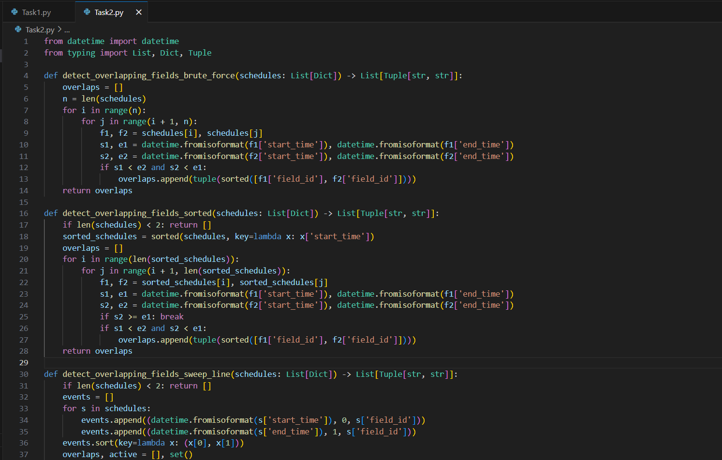
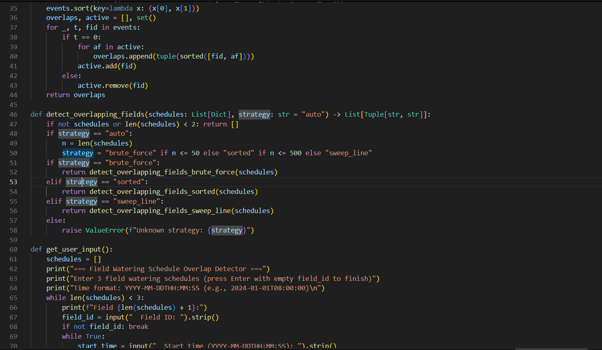
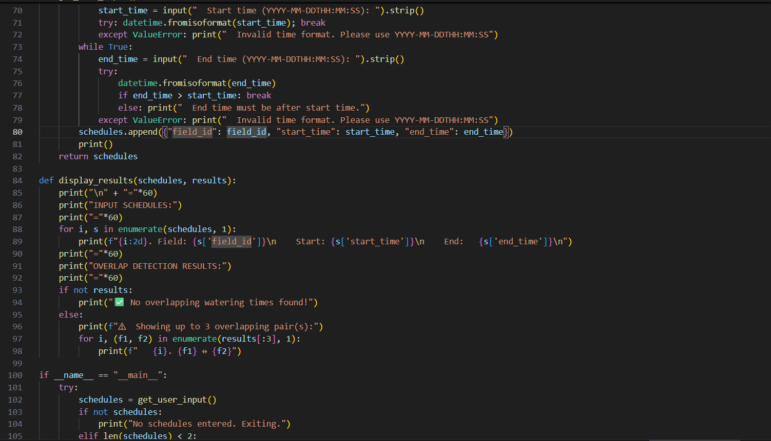
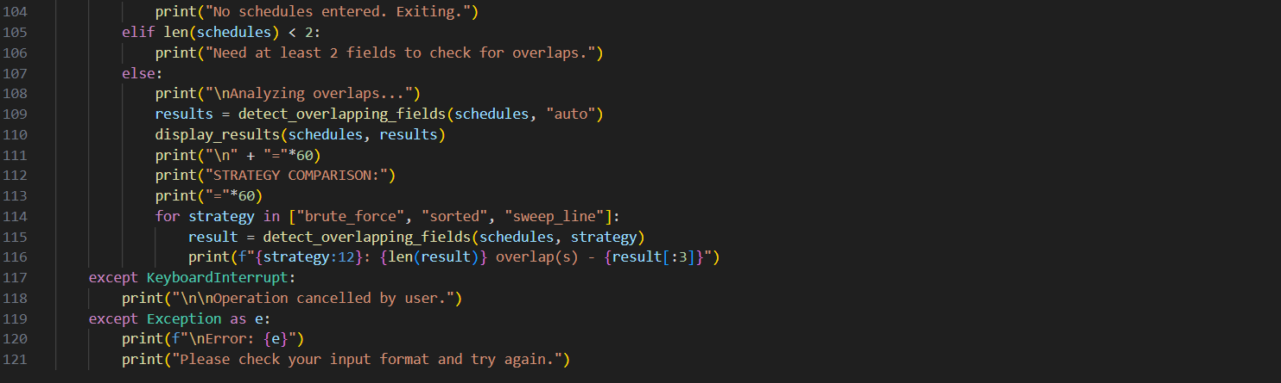
OUTPUT :
